# **Asynchronous Programming Exercises**

**Callbacks**

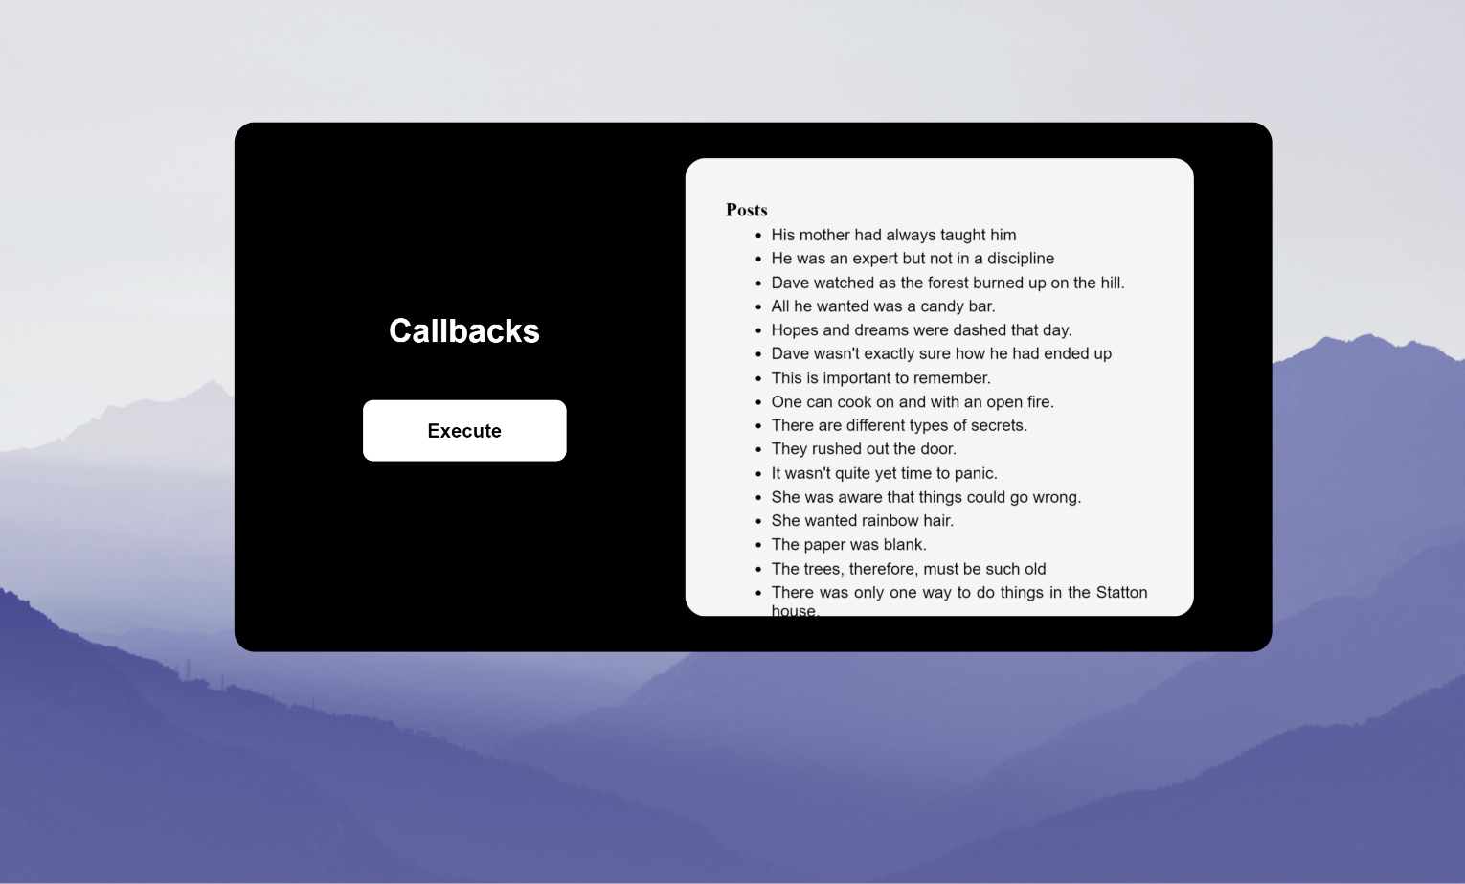

**Promises**

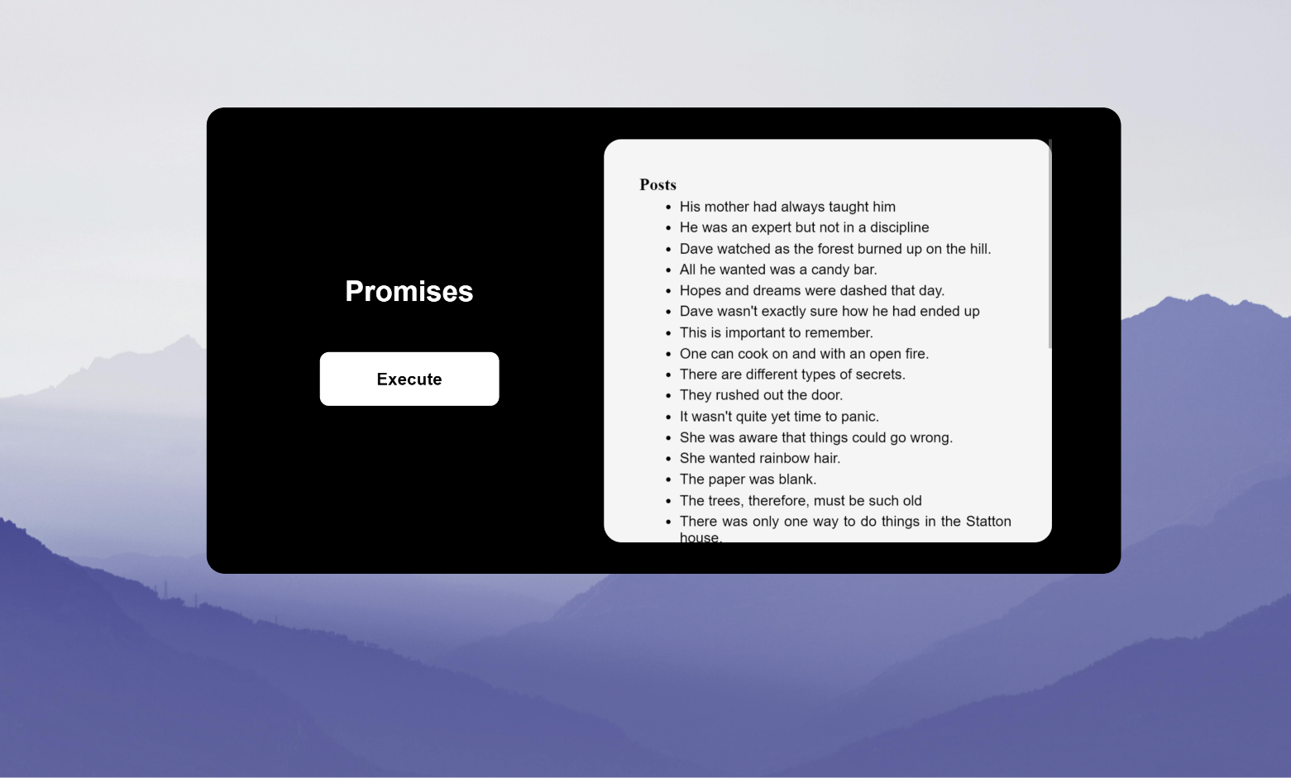

**Async-await**

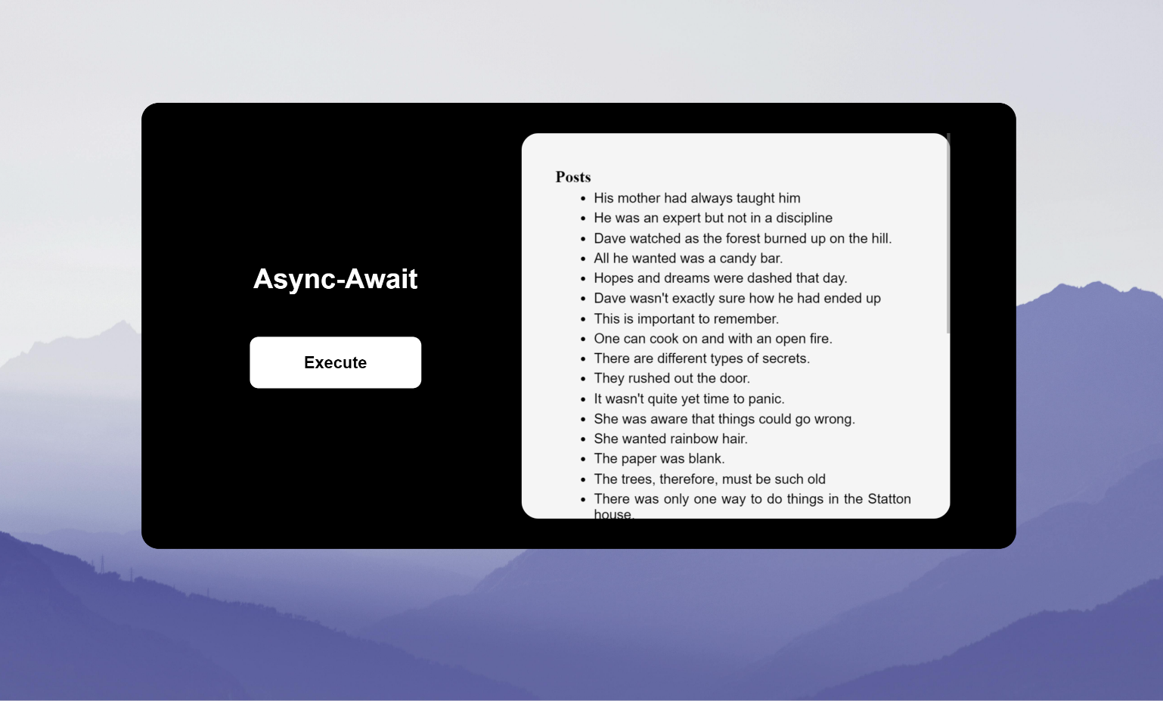

**GitHub Repository Link**

<https://github.com/Vaibhav-Dewangan/Asynchronous-Programming-Exercises.git>